WAG PRE-LEVELS SILVER – FLOOR (1)
Statics | 1. Tuck | 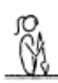 |  |  | - all positions must be performed with control and awareness  - maintain good body tension and alignment  - head neutral
 | 2. Pike | 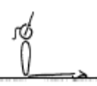 |  |  | - all positions must be performed with control and awareness  - maintain good body tension and alignment  - head neutral
 | 3. Closed Pike | 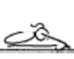 |  |  | - all positions must be performed with control and awareness  - maintain good body tension and alignment  - head neutral
 | 4. Front Support | 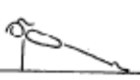 |  |  | - all positions must be performed with control and awareness  - maintain good body tension and alignment  - head neutral
 | 5. Rear Support | 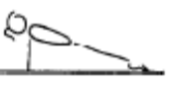 |  |  | - all positions must be performed with control and awareness  - maintain good body tension and alignment  - head neutral
 | 6. Squat | 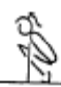 |  |  | - all positions must be performed with control and awareness  - maintain good body tension and alignment  - head neutral
 | 7. Layout |  |  |  | - all positions must be performed with control and awareness  - maintain good body tension and alignment  - head neutral
 | 8. © Dish | 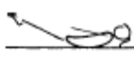 |  |  | - all positions must be performed with control and awareness  - maintain good body tension and alignment  - head neutral
 | 9. © Arch | 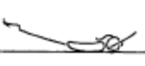 |  |  | - all positions must be performed with control and awareness  - maintain good body tension and alignment  - head neutral
 | 10. Shoulder stand/Candlestick | 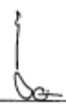 |  |  | - all positions must be performed with control and awareness  - maintain good body tension and alignment  - head neutral
 | 11. Floor Sequence – rear support, front support, jump to squat, layout position, Dish, roll to arch
Locomotion | 1. Seal Rolls with assistance – arch to dish – no hands or feet touching
Fwd Roll  (for front salto) | 1. F1-1.2 From stand, squat roll back through a tuck position to a momentary shoulder stand, roll fwd through tuck to stand | 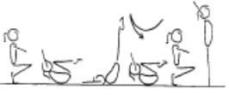 |  |  | - knees together, toes pointed  - ability to generated a smooth rocking action alone  - arms above head in shoulder stand position to  - enable a ‘chase’ action in the roll forward to stand  - hands on the front of the shins, below the  - kneecaps  - head tucked in, with chin on chest
 | 2. © Fwd roll to stand – no hands to stand | 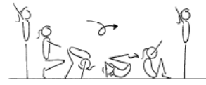 |  |  | - stretch before roll  - hands placed on the floor near the feet  - feet together  - tuck head under (look at belly button)  - roll quickly over the head  - roll should be in a neat, tight tuck, knees together and toes pointed  - roll up to stand  - stretch after roll

WAG PRE-LEVELS SILVER – FLOOR (2)
Handstand (for walkover, handspring and flic flac) | 1. © Angry Cat/Happy Cat position – hold 15 secs
 | 2. Angry cat on a box – hold 15 secs
 | 3. F1-2.3 Hold a static tuck handstand with knees supported on a box, or against a wall (this can be performed in a straddle and a pike | 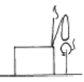 | - maintain good body tension and alignment  - hips under, chest in and head neutral  - fingers spread to assist in balance and give a  - broader base of support (middle finger should face slightly inward)  - emphasise to the gymnast the importance of  - keeping their hips in line with their wrists,  - shoulders and middle body
 | 4. F1-2.4 From a tuck position, jump to tuck handstand, rebound off the floor to tuck handstand x 10, non stop | 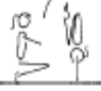 | - arms straight  - chest rounded, extended through the shoulders  - good closure during tuck, pike and straddle  - hips open  - gluteal muscles squeezed  - head neutral  - maintain good body tension and alignment
 | 5. Kick to “L” handstand
Cartwheel / Roundoff | 1. F1-4.2 with hands on a raised surface, jump from one side to the other | 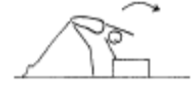 | - hands parallel, straight arms  - head neutral  - feet close to hands  - small straddle during the jump
 | 2. © F1-4.3 With hands on a raised surface, perform a cartwheel over and back | 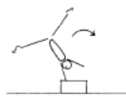 | - hands parallel, straight arms  - head neutral  - feet close to hands  - small straddle during the jump
 | 3. F2-3.1 Side cartwheel to side handstand position, the coach checks the posture and alignment | 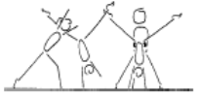 | - keep shoulders and hips square  - lunge into the side handstand  - head neutral  - maintain good body tension and alignment
 | 4. Angry cat position – rocking from hand to hand
Backward Roll (for back salto) | 1. F2-4.1 Have the gymnast lie on their back on a supersoft mat, their head is just off the edge, the gymnast places their hands on the floor and performs a backward roll. | 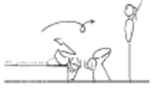 | - confidence and understanding  - legs together  - land on feet and stand  - use hands effectively
Stride Leaps | 1. F2-2.1 Have gymnasts “leap” across hoops which are spaced out on the floor | 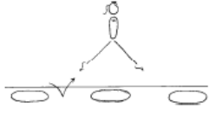 | - emphasise rhythm and form  - chin up, eyes down  - arms symmetrical  - hips and shoulders square
Leaps/Jumps | 1. Learn Attitude Position with foot on a box | 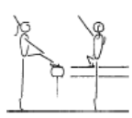 | - emphasise the turn out and toe point  - head up, eyes down  - good posture  - opposite arm to leg
 | ©2. Learn chasse – 1 x on each leg
Turns | 1. Side passé, fwd passé, releve – holding onto something stable
 | 2. © Straight Jump | 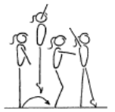 | - square hips and shoulders throughout the skill  - vertical take off  - extended toes, ankles, knees and hips in flight  - both heels on to the Beam on landing  - body vertical during landing
FWO, BWO & Tic Toc | 1. F2-5.1 Stand in front of a wall, perform back arch to contact hands on the wall and return to stand | 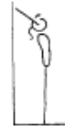 | - keep hips in line with feet  - stretch up first then open shoulders to initiate the back arch  - keep gluteal muscles tight  - maintain good body tension and alignment
 | 2. Kneeling shoulder stretch (pray to mecca)

MAG PRE-LEVELS SILVER – FLOOR (1)
Statics | 1. Tuck |  |  |  | - all positions must be performed with control and awareness  - maintain good body tension and alignment  - head neutral
 | 2. Pike |  |  |  | - all positions must be performed with control and awareness  - maintain good body tension and alignment  - head neutral
 | 3. Closed Pike |  |  |  | - all positions must be performed with control and awareness  - maintain good body tension and alignment  - head neutral
 | 4. Front Support |  |  |  | - all positions must be performed with control and awareness  - maintain good body tension and alignment  - head neutral
 | 5. Rear Support |  |  |  | - all positions must be performed with control and awareness  - maintain good body tension and alignment  - head neutral
 | 6. Squat |  |  |  | - all positions must be performed with control and awareness  - maintain good body tension and alignment  - head neutral
 | 7. Layout |  |  |  | - all positions must be performed with control and awareness  - maintain good body tension and alignment  - head neutral
 | 8. © Dish |  |  |  | - all positions must be performed with control and awareness  - maintain good body tension and alignment  - head neutral
 | 9. © Arch |  |  |  | - all positions must be performed with control and awareness  - maintain good body tension and alignment  - head neutral
 | 10. Shoulder stand/Candlestick |  |  |  | - all positions must be performed with control and awareness  - maintain good body tension and alignment  - head neutral
 | 11. Floor Sequence – rear support, front support, jump to squat, layout position, Dish, roll to arch
Locomotion | 1. Seal Rolls with assistance – arch to dish – no hands or feet touching
Fwd Roll  (for front salto) | 1. F1-1.2 From stand, squat roll back through a tuck position to a momentary shoulder stand, roll fwd through tuck to stand |  |  |  | - knees together, toes pointed  - ability to generated a smooth rocking action alone  - arms above head in shoulder stand position to  - enable a ‘chase’ action in the roll forward to stand  - hands on the front of the shins, below the  - kneecaps  - head tucked in, with chin on chest
 | 2. © Fwd roll to stand – no hands to stand |  |  |  | - stretch before roll  - hands placed on the floor near the feet  - feet together  - tuck head under (look at belly button)  - roll quickly over the head  - roll should be in a neat, tight tuck, knees together and toes pointed  - roll up to stand  - stretch after roll

MAG PRE-LEVELS SILVER – FLOOR (2)
Handstand (for walkover, handspring and flic flac) | 1. © Angry Cat/Happy Cat position – hold 15 secs
 | 2. Angry cat on a box – hold 15 secs
 | 3. F1-2.3 Hold a static tuck handstand with knees supported on a box, or against a wall (this can be performed in a straddle and a pike |  | - maintain good body tension and alignment  - hips under, chest in and head neutral  - fingers spread to assist in balance and give a  - broader base of support (middle finger should face slightly inward)  - emphasise to the gymnast the importance of  - keeping their hips in line with their wrists,  - shoulders and middle body
 | 4. F1-2.4 From a tuck position, jump to tuck handstand, rebound off the floor to tuck handstand x 10, non stop |  | - arms straight  - chest rounded, extended through the shoulders  - good closure during tuck, pike and straddle  - hips open  - gluteal muscles squeezed  - head neutral  - maintain good body tension and alignment
 | 5. Kick to “L” handstand
Cartwheel / Roundoff | 1. F1-4.2 with hands on a raised surface, jump from one side to the other |  | - hands parallel, straight arms  - head neutral  - feet close to hands  - small straddle during the jump
 | 2. © F1-4.3 With hands on a raised surface, perform a cartwheel over and back |  | - hands parallel, straight arms  - head neutral  - feet close to hands  - small straddle during the jump
 | 3. F2-3.1 Side cartwheel to side handstand position, the coach checks the posture and alignment |  | - keep shoulders and hips square  - lunge into the side handstand  - head neutral  - maintain good body tension and alignment
 | 4. Angry cat position – rocking from hand to hand
Backward Roll (for back salto) | 1. F2-4.1 Have the gymnast lie on their back on a supersoft mat, their head is just off the edge, the gymnast places their hands on the floor and performs a backward roll. |  | - confidence and understanding  - legs together  - land on feet and stand  - use hands effectively
Stride Leaps | 1. F2-2.1 Have gymnasts “leap” across hoops which are spaced out on the floor |  | - emphasise rhythm and form  - chin up, eyes down  - arms symmetrical  - hips and shoulders square
Jumps | 1. © Straight Jump |  | - square hips and shoulders throughout the skill  - vertical take off  - extended toes, ankles, knees and hips in flight  - both heels on to the Beam on landing  - body vertical during landing
FWO, BWO & Tic Toc | 1. F2-5.1 Stand in front of a wall, perform back arch to contact hands on the wall and return to stand |  | - keep hips in line with feet  - stretch up first then open shoulders to initiate the back arch  - keep gluteal muscles tight  - maintain good body tension and alignment
 | 2. Kneeling shoulder stretch (pray to mecca)

PRE-LEVELS SILVER – BARS (1)
Hanging & Grip Strength | 1. © GF5.3 Bar Sequence – Pike inverted hang is linked to a stride hang. Return to ground and jump to ft support, fwd roll to hang
Tuck Swings /Glides | 1. B1-3.3 Have the gymnast practice moving their hands around the bar releasing and regripping at the back of the ‘pretend’ swing | 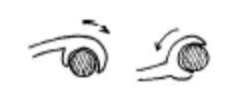 | - relaxed hands  - good understanding of the front and back of the  - swing
 | 2. © Tuck swings re-grip (assist x 3) | 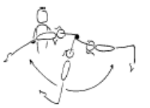 | - gymnast must maintain good body tension and  - alignment
 | 3. Show glide position with feet resting on a box
Front Support /Casts | 1. © B1-1.1 Windscreen wipers on Floor | 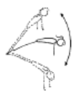 | - straight arms throughout the jump to front support  - chest rounded
 | 2. Jump to front support (good technique) repeat x 3 | 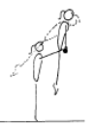 | - straight arms throughout the jump to front support cast to land phase  - chest rounded on the bar  - good use of swing during the cast phase
 | 3. B1-1.2 In front support on the bar shoulder shrugs | 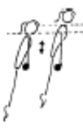 | - straight arms throughout the jump to front support  - chest rounded
 | 4. GF4.9 Cross the alligator pit in front support
Fwd Roll Dismount | 1. B1-2.1 Tuck leg lifts on wedge x 3 | 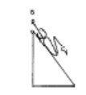 | - maintain good body tension and alignment  - knees to chest
 | 2. Roll fwd on the bar, show tuck hang hold - spotted | 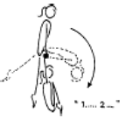 | - straight arms throughout the front support phase  - chest rounded on the bar  - tight tuck in the roll forward  - knees to chest in the tuck hold
Pullover | 1. Holding toes to the bar on own – 5 secs
 | 2. © Chin up hold on own – 5 secs
 | Swing on rings in 3. tuck position 3 x fwd and bwd (with box under so gymnast remains in tuck position)

PRE-LEVELS SILVER – BEAM (1)
Front support Mount | 1. © M1-1.3 Learn the squat position on the floor and/or low beam | 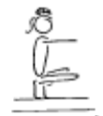 | - arms straight and stretched  - shoulders upright  - balance on balls of the feet  - knees tight together
 | 2. Front support, straddle over, hold squat | 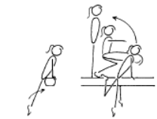 | - straight arms in front support  - legs straight during the first phase  - during the swing to squat, or lift feet behind, keep arms straight and head neutral  - in the squat have shoulders upright and weight on the balls of the feet
Kneeling Scale | 1. M1-3.1 Bear walk on beam | 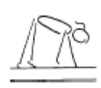 | - arms straight  - good rhythm  - head up, eyes down
Arabesque /Posture | 1. M2-5 Low scale L & R with back leg resting on low beam
Attitude Steps | 1. M1-5.1 Attitude steps on end of beam – resting front foot on a box in attitude position
Releve/Turns | 1. M1-2.1 Releve on the beam – held for 5 sec x 2 | 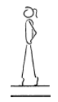 | - one foot slightly in front of the other, both legs slightly turned out  - legs squeezed together  - legs straight, knees locked  - heels pushed forward into a high arch shape  - ankles should be stable  - equal weight on both feet  - maintain good body tension and alignment
 | 2. © M1-7.2 Learn fwd passé position
Locomotion | 1. Walk on toes to the end – hands on hips
 | 2. © GF3.9 Walking backwards along low beam/bench, ½ turn on toes and straight jump off
 | 3. M2-3 Running along bench/low beam | 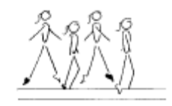 | - good rhythm  - confidence  - good body alignment and control  - εextended toes, ankles, knees and hips
 | 4. M1-3.1 Caterpillar on beam
Jumps /Leaps | 1. M1-10.1 Have gymnast stand on the beam, arms swing fwd and upward as gymnast moves into a releve hold for 5 secs, then lower into a small plie arms swing downward to land in front and present | 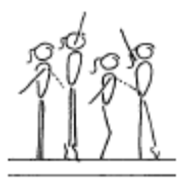 | - ensure efficient use of arms  - ensure shoulders upright at all times  - knee bend should not exceed 45’  - heels pushed forward into a high arch position  - hips under and stomach pulled in  - head up and eyes down  - emphasise square hips and shoulders during take off and landing
 | 2. © Jumps in 5th position – on bench
Stride Leap | 1. M3-2.1 Long stretch steps along the beam | 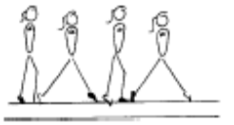 | - arms side horizontal  - square hips and shoulders  - keep body upright
Handstand | 1. © M3-4.1 Front support with hands on a low beam and feet on a box – performed to the front | 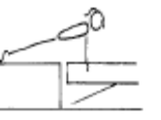 | - shoulders and hips square  - hips under, chest in  - head neutral
Landing Drills | 1. Can you move me/ shake me in landing position | 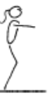 | - on landing the hips must be under  - on landing the shoulders, hips and ankles should all be in a vertical line
 | 2. Clap – don’t jump off beam until coach claps
Straight Jump Dismount | 1. M1-6.1 Straight jump (and other positional jumps) off a board to land
 | 1. © M1-6.1 Straight jump (and other positional jumps) off a low beam to land | 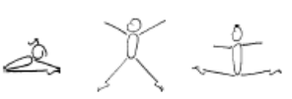 | - vertical take off  - correct position in the air  - control body on landing

PRE-LEVELS SILVER – VAULT (1)
Landing | 1. V1-2.1 Landings off a box - star
 | 2. © GF2.6 Jump backwards off a box and land
Bounce /Spring | V1-1.2 Assisted bounces on the board, coach holds gymnast by hands
 | 2. V1-5 Springing circuit – 5 low objects | 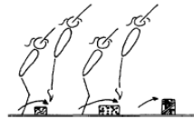 | - maintain good body tension and alignment  - continuous bouncing, no pauses or stops  - easy clearance of the objects
 | 3. V1-4.1 Stand with the rope in front, jump over it, swing the rope overhead and repeat
 | 3. © GF3.7 5 x hopping steps on each leg
Running | 1. Running | 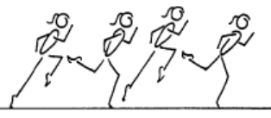 | - good body alignment  - fast action  - arms bent at 90', moving beside body  - legs moving within the body line  - body straight with slight forward lean  - maximum forward speed is essential  - head remains neutral and still
Hurdles | 1. GF3.7 Run, Hurdle on Floor – arms down when feet land
Straight Jump Vault | 1. © V2-3.3 – step off a box to a board, straight jump land | 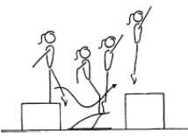 | - underarm action  - arms stop at 45’  - low approach from the box to the board  - feet lead body onto the board  - fast explosive bounce off the board  - vertical bounce off the board  - maintain tight straight body shape, with chest in, on the box
 | 2. V1-3 Step from a low box to a board bounce up to a box
Handstand Flatback | 1. V2-1.2 Shoulder shrugs - standing
Dive Roll / Front Salto | 1. Run along bench – mini-tramp, tuck jump to land on 60cm box

